
TROY SecurePort Monitor
For TSOM Users Guide

Rev. A

TABLE OF CONTENTS

Section 1 Introduction 3
Section 2 Installation 4
Section 3 Printing 8
Section 4 Configuration 10
Section 5 Using Fonts 15
Section 6 Enabling TROY Features 20
Section 7 SecurePort Monitor Configuration Utility 24
Section 8 Adding New Secure Ports 30

Section 1 Introduction

The TROY SecurePort Monitor (TSM) is a Windows-based printer port that manages and configures all print data sent from a TROY Security Printer Solution. A version of the TSM has been created that works exclusively with the TROY Secure Output Manager (TSOM) solution. This Users Guide describes how to use the TSOM version of TSM.

The role of TSM in a TSOM solution is to insert into a print job the printer commands that will invoke the MICR and security features on the TROY printer. TSOM passes the data associated with the MICR and security features to the TSM using serialized printer data (PCL 5 data) embedded in the print job. The serialized data must be set to a unique font not used anywhere else in the printed document. The font is configured in TSOM and in the TSM.

The Troy Secure Port Monitor consists of two components: the Troy Port Monitor Service and the TROYPORT Printer Port.

The TROYPORT Printer Port is a Windows-based port monitor. A typical port monitor provides a link between the printer spooler and a printer. The printer spooler directs a print job to the TROYPORT port monitor. Instead of sending the print job to a printer, the TROYPORT port monitor directs print jobs to the Troy Port Monitor Service by printing the data to a file in a specified folder.

The Troy Port Monitor Service is a Windows Service that monitors the folder where the print job is written. When a file is created in the folder, the service uses configuration information to determine what adjustments are to be made to the print job before sending it onto the destination printer. The destination printer is defined in the configuration or in the job itself.

A TROYPORT can be used to direct the output from an application to the TSOM application. The TROYPORT is used as a print to file print port. This configuration is referred to as an unmonitored port throughout the remainder of this document because the output of the specific TROYPORT is not monitored by the Troy Port Monitor Service. An unmonitored port can be created using the TROY Add SecurePort Utility described later.

Section 2 Installation

Follow the steps below to install the TSM:

- Run the TSM Installation Wizard
The TSM installation consists of a single .msi file. Double-click the .msi file to begin the installation process.

- Follow the TSM Installation Wizard instructions.
The Installation Wizard provides easy-to-use instructions for installation on your system. Follow the wizard screens to continue the installation. The Installation Complete window will appear after a successful install.

Note: The Microsoft .NET Framework 3.5 will be installed on your system if it has not already been installed. This will require a live internet connection. This may require a reboot after completion. The installation should restart automatically after the reboot. If the installation does not restart automatically, then return to step 1.
- Create a new printer linked to the TROYPORT1: port monitor.
To add a printer, go to Start Menu -> Printers and Faxes or Start Menu -> Settings -> Printers.
Select Add Printer. Follow these steps in the Add Printer Wizard:

  - In the Local or Network Printer screen, select “Local printer attached…” and uncheck the “Automatically detect and install…”check box.

  - In the Select a Printer Port wizard screen, select “Use Existing Port” or “Use the following port:” and then select TROYPORT1: from the drop-down list. (see figure below)

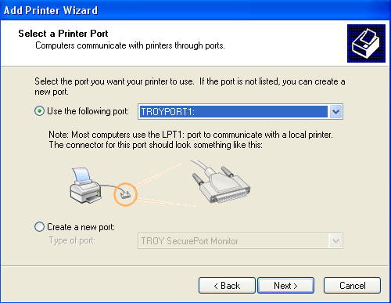
Figure 2.1: Select the TROYPORT1: port in the Select a Printer Port screen.

- In the Install Printer Software screen, select an existing HP PCL 5 driver from the list or browse (using Have Disk…) to the TROY CD and select the appropriate printer driver for you operating.

- In the Use Existing Driver screen (if it appears), select “Keep existing driver”

- In the Name Your Printer screen, enter a recognizable name like TROY SecurePort Monitor 1. Unless otherwise directed by a TROY representative, do not set the printer to the default printer.

- In the Printer Sharing screen, select “Do not share this printer”.

- In the Print Test Page screen, select No.

Section 3 Configuration

In most cases the TSM will not need changes made to the configuration included in the installation. This section describes how to make configuration adjustments if directed to do so by a TROY representative.

Troy SecurePort Monitor Configuration Utility

The Troy SecurePort Monitor Configuration Utility can be used to adjust configuration. A shortcut to the utility can be found in the Start Menu. Click on the shortcut to open the utility.

At the top of the screen that appears, select the Troy Secure Port from the drop-down list. After selecting a secure port, the tabs will become enabled.

Configuration Tab

The Configuration tab contains settings for the following:

Default Printer (Optional)

The serialized data from TSOM in most cases will contain a destination printer. The TSM will direct print jobs to the destination printer after inserting the MICR/security features. If the serialized data does not contain a printer, the Default Printer will be used if defined.

TSOM Serialized Data Font

This is the unique font used by TSOM to create the serialized data. This setting must match the font defined in the TSOM configuration. TSM will use all data set to this font as serialized data.

File Open Settings

The TSM must wait for the print spooler to write all the print data to a file before the file can be opened. When printing across a network or when printing large files, the print spooler may take longer than usual to produce the file. The File Open Settings can be used to lengthen the amount of time the TSM waits for the file to be written before timing out. The File Open Delay Time is the number of milli-seconds between each attempt to see if a file is completely written. The File Open Attempts is the amount of attempts the TSM makes to open a file before the timeout occurs.

Duplexing

The TSM is capable of inserting commands to enable duplexing if needed. In most cases this value will remain at Do Not Adjust. Do not adjust unless directed by a Troy representative.

End Of Page Settings

The end of page settings is a list of PCL 5 commands that mark the end of page. TSM is preset with the typical strings. Do not adjust unless directed by a Troy representative.

Insert Point

The insert point is a PCL 5 command marking the location of the first printed character where the Troy MICR/security features should be inserted. Do not adjust unless directed by a Troy representative.

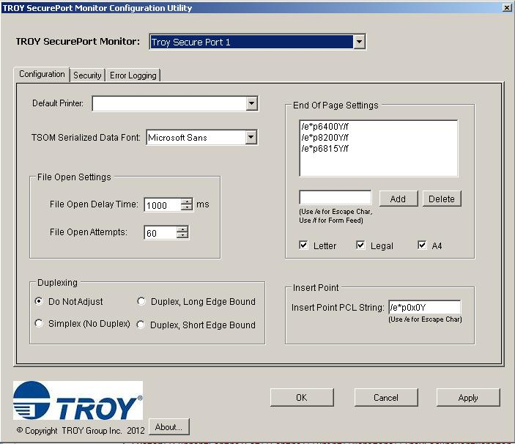

Security Tab

The Security tab contains settings for security features on a Troy printer. These features include:

Personal Identification Numbers (PIN)

This section contains settings for the various pins available on certain Troy printers. The features are described in more detail in documentation included with the printer.

Encryption

Troy printers can be configured for encryption/decryption. The TSM can encrypt a print job prior to sending it to the printer. The printer can then be configured using the Troy Printer Utility (available on the Troy Group website) to decrypt the printer job. The password configured in the TSM and the Troy Printer Utility must match.

TROY Printer Login/Password

Troy printers can be configured to require a login prior to printing MICR and security features. The TROY Printer Login/Password can be used to direct the TSM to insert the login information into the print job.

TROY Legacy Features

The TROY Legacy Features section is used to configure the TSM for features that are available on older models of Troy printers. Check with a Troy representative to determine if the legacy features are available on your Troy printer.
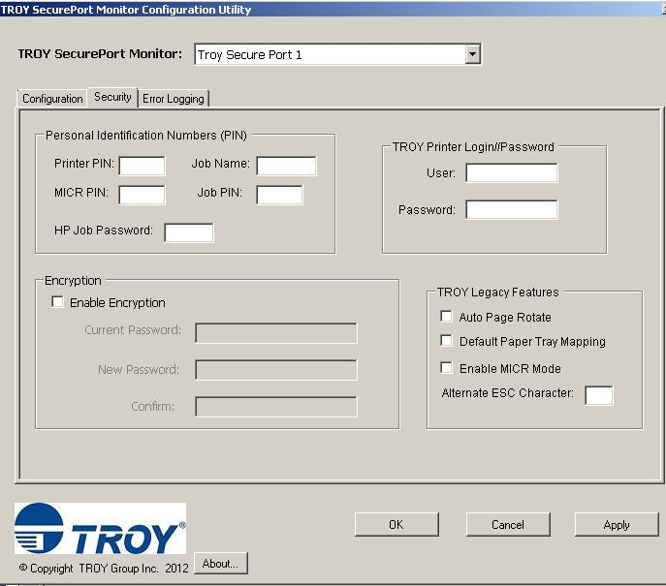

Error Logging Tab

The Error Logging tab provides tools for debugging issues with the TSM. These features include:

Log Error To Windows Event Log

This value is set to true by default. Errors that occur in the TSM are logged to the Event Log as Application log with a Source of Troy Secure Port Monitor.

Enable Error Message Boxes

By default, most Windows operating systems will not allow a service to open a message box. Therefore, this setting should remain turned off.

Error Log Path

If blank, error logging to a file is disabled. If the value is set to a valid path or set to the word default, errors will be logged to a file. The default location is the Error Log folder under the PrintPort folder. The file name included the date of when the error occurred.

Save Data File Path

The simplest way for a Troy representative to debug an issue is to recreate the issue using the print job file. The Save Data Files Path feature is used to save the print job files to a folder after they’ve been processed. If the value is blank, the feature is disabled. The value can be set to default or to a valid path. The default location is the Backup folder under the PrintPort folder.

Advanced Error Logging Settings

The advanced error logging settings can be used to debug issues where the Troy features are not appearing on the print out or the job is going to the incorrect printer.

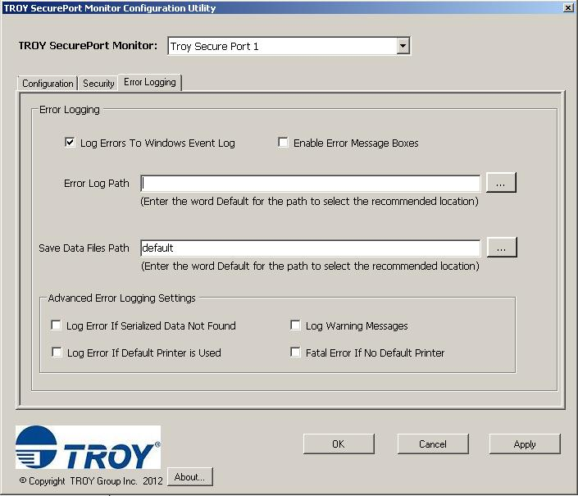

Troy Add SecurePort Utility

If additional TROYPORTs are needed, the Add Troy SecurePort Utility should be used. The utility has a check box with the text Use TROYPORT as a Stand-Alone Printer Port. This should be checked if the TROYPORT will be used as an unmonitored port.

